The News

Mrs. Leestma’s Class  **Concord Academy Petoskey** October 12, 2015

**Dates to Remember**

**October 21**

**Girls Book Club**

**3:00-4:00 $5.00**

**October 28**

**Picture retakes**

**October 30**

**Character Dress-Up Day**

**School News**

~ Progress reports are in your

child’s Monday folder. Please

contact me with any questions or concerns.

**Class Curriculum**

**Math:**

fractions

temperature

centimeters

ordering numbers

**Social Studies/Science:**

Motion

**I-Search examples:**

pencils

pandas

bamboo

Walt Disney

**Language/Spelling:**

comparative/superlative adjectives

synonyms

conventions

**Writing:**

opinion

**Directed Reading:**

Because of Winn Dixie

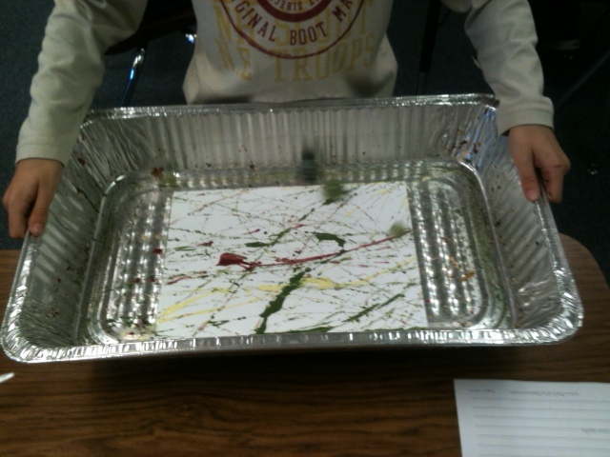

Marbles in Motion

Learning target:

I can make observations and/or measurements of objects in motion to provide evidence that a pattern can be used to predict motion.

**HELP WANTED!**

Our class news paper will be sent home every other week. I would like the students to be responsible for the paper, collecting and writing news, taking pictures and designing the layout. I would also like a volunteer to guide the students. The volunteer would be responsible for a group of four students and would lead them to complete the paper on time. I am flexible to the volunteers schedule as long as it does not interfere with the student’s art classes, math or recess/lunch. If you are interested please let me know. I am excited to make this a student lead project!

Thanks to Mrs. Hall, Clementine’s Grandmother, the **students** are in the process of updating our class Weebly.! **Thank you Mrs. Hall!!!**

**Mrs. Leestma**

**School:**

231- 439-6800

**Email:**

[cleestma@concordpetoskey.com](mailto:cleestma@concordpetoskey.com)

**Weebly:**

[www.cleestmacap.weebly.com](http://www.mrsfettig.weebly.com)

"A person's a person no matter how small.”

Horton Hears a Who!

By Dr. Seuss